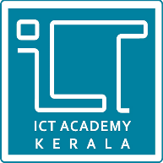

**ICTAK LEARNER TRACKER**

**Submitted By**

AMANA HUSSAIN

ANUSHA ANIL

NEETHU S NAIR

PREMY PRASAD

VAISHAK C KRISHNAN

CERTIFIED SPECIALIST IN FULL STACK DEVELOPMENT (MEAN)

[Kerala Knowledge Economy Mission (KKEM](https://retail.ictkerala.org/course/view.php?id=231))

**ICT ACADEMY OF KERALA**

**JULY 2022**